### ****What is a Fuse?****

A **fuse** is an **electric** / **electronic or mechanical device**, which is used to protect circuits from over current, overload and make sure the protection of the circuit. Electric fuse was invented by Thomas Alva Edison in 1890. There are many types of fuses, but the function of all these fuses is the same. In this article, we will discuss the different types of fuses, its construction, working and operation and their application in various electronics and electrical systems.

[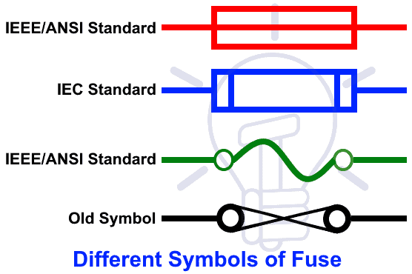](https://www.electricaltechnology.org/wp-content/uploads/2014/11/Different-Symbols-of-Fuse-IEC-IEEE-ANSI.png)

IEC & IEEE/ANSI Symbols of Fuse

### ****Construction & Working of a Fuse****

A general Fuse consists of a low resistance metallic wire enclosed in a non combustible material. It is used to connect and install in series with a circuit and device which needs to be protected from short circuit and over current, otherwise, electrical appliance may be damaged in case of absence of the fuse and circuit breaker as they are unable to handle the excessive current according to their rating limits

The **working principle of a fuse** is based on the “**Heating effect of Current**” i.e. Whenever a short circuit, over current or mismatched load connection occurs, then the thin wire inside the fuse melts because of the heat generated by the heavy current flowing through it. Therefore, it disconnects the power supply from the connected system. In normal operation of the circuit, fuse wire is just a very low resistance component and does not affect the normal operation of the system connected to the power supply.

[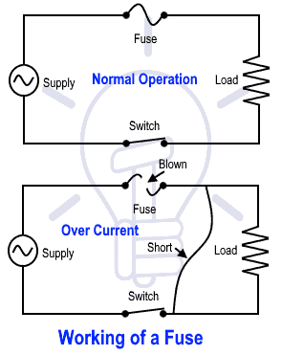](https://www.electricaltechnology.org/wp-content/uploads/2014/11/Working-of-a-Fuse.png)

Working of a Fuse

### ****How to Select Proper Rating Size of Fuse?****

While selecting the proper fuse and its rated size for an electrical appliance is based on different factors and environments. But the following basic formula shows **how to choose the right size of fuse**?

**Fuse Rating = (Power / Voltage) x 1.25**

For example, you have to find the right size of fuse for 10A two pin sockets.

(1000W / 230V) x 1.25 = **5.4A**

In the above example, 1kW is the power rating which can be controlled through the 2 pin socket and the main supply voltage is single phase 230V AC (120V AC in US).

But you should go for the max i.e. 6A fuses rating instead of 5.4A for safe and reliable operation of the circuit.

### 1. DC Fuse

AC and DC fuses can be differentiated by their size. Since DC has a constant value greater than zero volt (0v), there will be a chance of occurrence of an electric arc between the melted wires. As it is difficult to avoid, the electrodes are placed at larger distance compared to AC fuses.

### 2. AC Fuse

AC Fuses are further categorized into two broad categories based on the amplitude of applied voltage. They are:

* Low Voltage Fuses
* High Voltage Fuses

#### 2.1 Low Voltage Fuse

As the name suggests, these are the fuses that are used in low voltages. Some of the Low Voltage Fuses are listed below.

#### 2.1.1 Rewireable Fuse

Rewireable fuses (also known as Kit-Kat fuses) are of Low voltage type fuses. They are mainly used in small scale industries and house wiring. It consists of 2 parts namely:

* **Fuse Base**: Contains in and out terminal. It is made up of porcelain.
* **Fuse link Carrier**: It holds the main element and is made up of aluminium, copper or lead.

[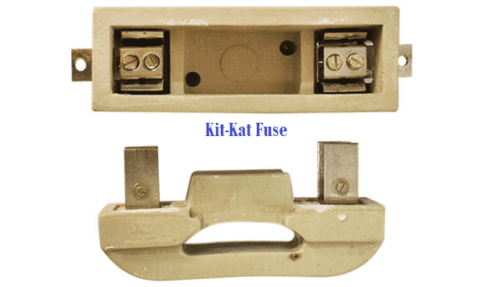](https://i0.wp.com/electricalfundablog.com/wp-content/uploads/2019/04/Rewireable-Kit-Kat-Fuse.png?ssl=1)

**Fig. 5 – Rewireable (Kit-Kat) Fuse**

The fuselink carrier can be easily removed from the base without any electric shock. When it blows out, we can easily remove the fuselink carrier and replace the wire.

#### 2.1.2 Cartridge Fuse

Cartridge Fuses are also known as Totally Enclosed type Fuses. The fuselinks are enclosed in the glass container. By having this type of design, it helps to keep the electric arc inside the container when it blows out.

[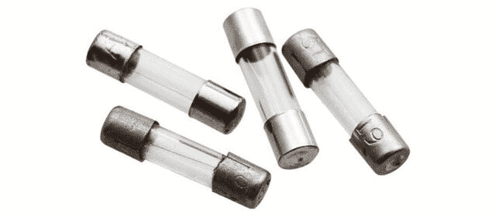](https://i0.wp.com/electricalfundablog.com/wp-content/uploads/2019/04/Cartridge-Type-Fuse.png?ssl=1)

**Fig. 6 – Cartridge Type Fuses**

They are used in many electrical and electronics appliances. They not only protect the device but also prevents fire caused by overheating of the circuits. These type of fuses are used in both Low voltage and high voltage.

Cartridge fuses are further classified into following two types:

* ‘D’ Type Fuses
* Link Type Fuses

#### 2.1.2.1 ‘D’ Type Fuse

Diazed type fuses are made of bottle shaped ceramic body with metal end caps. ‘These fuses are highly reliable. It consists of cartridge, base, adapter ring and a cap. The cartridge is fitted with a cap and inserted into the base using the adapter ring.

[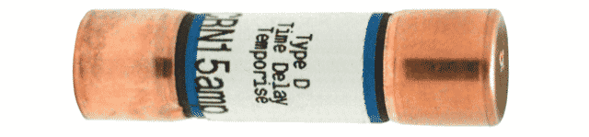](https://i0.wp.com/electricalfundablog.com/wp-content/uploads/2019/04/D-Type-Fuse.png?ssl=1)

**Fig. 7 – ‘D’ Type Fuses**

#### 2.1.2.2 Link Type Fuse

Link type fuses are also known as High Rupturing Cartridge (HRC) fuses. The current flows under normal condition through the element. The body is made up of porcelain and the chamber of main element is filled with silica sand.

If short circuit occurs then the high current flows through it for some amount of time. If the fault is cleared then it will not blow out. But if the high current continues to flow for longer duration then it blows out by melting the element.

There are 2 types of HRC fuses namely,

* Blade Type Fuses
* Bolted Type Fuses

[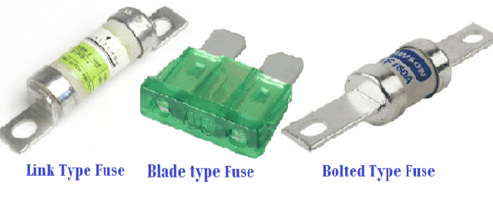](https://i0.wp.com/electricalfundablog.com/wp-content/uploads/2019/04/Link-Type-D-Type-and-Bolted-Type-Fuse.png?ssl=1)

**Fig. 8 – Link Type, ‘D’ Type and Bolted Type Fuses**

#### 2.1.3 Switch Type Fuse

It encloses a metal switch and the fuse. These types of fuses are used in low and medium voltage levels.

[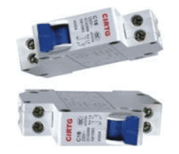](https://i0.wp.com/electricalfundablog.com/wp-content/uploads/2019/04/Switch-Type-Fuse.png?ssl=1)

2.2 High Voltage Fuse

As the name suggests, these are the fuses that are used in high voltages. Some of the High Voltage Fuses are listed below.

2.2.1 Liquid Type HRC Fuse

Liquid type HRC fuses are most commonly used in high voltage circuits. These types of fuses are mainly used for transformer protection and circuits which have more than 400A.

[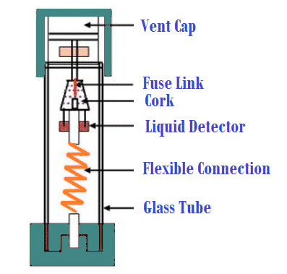](https://i0.wp.com/electricalfundablog.com/wp-content/uploads/2019/04/Liquid-Type-HRC-Fuse.png?ssl=1)

**Fig. 10 – Liquid Type HRC Fuses**

Liquid type HRC fuses are filled with carbon tetrachloride. When there is a short circuit, the current passes through the element which melts and break. The liquid used in the fuses extinguish the arc created by the short circuit.

**2.2.2 Cartridge type HRC Fuse**

These type of fuses are similar to low voltage fuses. It is in the shape of a ring for removing the corona effect. Two fuse elements are used in it which are placed parallel to each other. The elements are made up of tungsten metal due to high resistance property.

[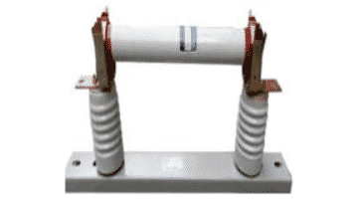](https://i0.wp.com/electricalfundablog.com/wp-content/uploads/2019/04/Cartridge-Type-HRC-Fuse.png?ssl=1)

**Fig. 11 – Cartridge Type HRC Fuses**

2.2.3 Expulsion Type HRC Fuse

Expulsion type of fuses are used to protect transformers and feeders. It is designed for 11kv and limit is up to 250 MVA. The fuse element is placed inside the cylinder and the tops are linked to the equipment. These fuses have a cylinder designed with synthetic resin bond paper.

[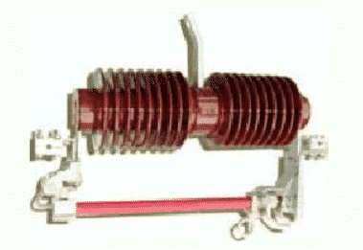](https://i0.wp.com/electricalfundablog.com/wp-content/uploads/2019/04/Expulsion-Type-HRC-Fuse.png?ssl=1)

**Fig. 12 – Expulsion Type HRC Fuses**

Applications of a Fuse

The applications of Fuses include nearly all electrical/ electronic devices such as:

* Electrical wiring at home.
* Appliances like AC, Refrigerator, TV, Washing machine etc.
* Laptops.
* Mobile chargers.
* Automobiles (Cars, Trucks, Buses, etc).

Advantages of Fuses

The advantages of Fuses includes:

* Fuses are cheapest form of protection available.
* No maintenance is required.
* When compared to circuit breakers, fuses require less time to react when circuit breaks.

Disadvantages of Fuses

The disadvantages of Fuses includes:

* Considerable time is lost due to rewiring the fuses after operation.
* The current time characteristics of fuses cannot be related with that of protected apparatus.